**Pizza Sales SQL Queries**

**KPI’s:**

1. **Total Revenue:**

SELECT ROUND(SUM(total_price), 2) AS Total_Revenue

FROM pizza_sales

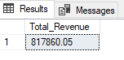

1. **Average Order Value:**

SELECT ROUND(SUM(total_price) / COUNT(DISTINCT order_id), 2) AS Avg_order_Value

FROM pizza_sales

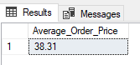

1. **Total Pizzas Sold:**

SELECT SUM(quantity) AS Total_pizzas_sold

FROM pizza_sales

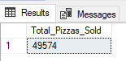

1. **Total Orders:**

SELECT COUNT(DISTINCT order_id) AS Total_Orders

FROM pizza_sales

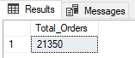

1. **Average Pizzas Per Order:**

SELECT SUM(quantity) / COUNT(DISTINCT order_id) AS Avg_Pizzas_Per_Order

FROM pizza_sales

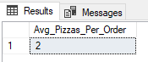

**Daily Trend of Total Orders:**

SELECT

DATENAME(DW, order_date) AS Order_Day,

COUNT(DISTINCT order_id) AS Orders

FROM pizza_sales

GROUP BY DATENAME(DW, order_date)

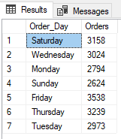

**Monthly Trend of Total Orders:**

SELECT

DATENAME(MONTH, order_date) AS Order_Month,

COUNT(DISTINCT order_id) AS Orders

FROM pizza_sales

GROUP BY DATENAME(MONTH, order_date)

ORDER BY MIN(MONTH(order_date))

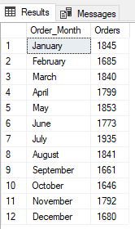

**Percentage of Sales by Pizza Category:**

SELECT

pizza_category,

ROUND(SUM(total_price), 2) AS Total_Sales,

ROUND(SUM(total_price) * 100 / (SELECT SUM(total_price) FROM pizza_sales), 2) AS PCT

FROM pizza_sales

GROUP BY pizza_category

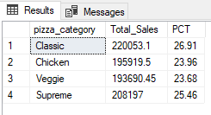

**Percentage of Sales by Pizza Size:**

SELECT

pizza_size,

ROUND(SUM(total_price), 2) AS Total_Sales,

ROUND(SUM(total_price) * 100 / (SELECT SUM(total_price) FROM pizza_sales), 2) AS PCT

FROM pizza_sales

GROUP BY pizza_size

ORDER BY PCT DESC

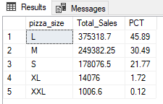

**Top 5 Pizzas by Sales:**

SELECT TOP 5

pizza_name,

SUM(total_price) AS Total_Sales

FROM pizza_sales

GROUP BY pizza_name

ORDER BY Total_Sales DESC

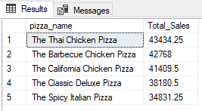

**Bottom 5 Pizzas by Sales:**

SELECT TOP 5

pizza_name,

ROUND(SUM(total_price), 2) AS Total_Sales

FROM pizza_sales

GROUP BY pizza_name

ORDER BY Total_Sales ASC

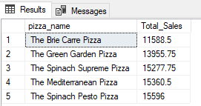

**Top 5 Pizzas by Quantity:**

SELECT Top 5

pizza_name,

SUM(quantity) AS Total_Pizzas_Sold

FROM pizza_sales

GROUP BY pizza_name

ORDER BY Total_Pizzas_Sold DESC

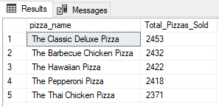

**Bottom 5 Pizzas by Quantity:**

SELECT Top 5

pizza_name,

SUM(quantity) AS Total_Pizzas_Sold

FROM pizza_sales

GROUP BY pizza_name

ORDER BY Total_Pizzas_Sold ASC

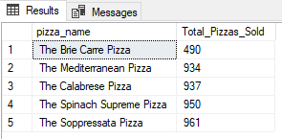

**Top 5 Busiest Hours of the Day:**

SELECT TOP 5

DATEPART(hour, order_time) AS Hour_of_the_Day,

COUNT(DISTINCT order_id) AS Number_of_Orders,

SUM(quantity) AS Total_Pizzas_Sold,

ROUND(SUM(total_price), 2) AS Total_Sales

FROM pizza_sales

GROUP BY DATEPART(hour, order_time)

ORDER BY number_of_orders DESC

